Here we validate the dispersion computation of designs that contain void voxels against an identical Comsol model.
The comsol model is saved in this folder as:
3D-dispersion-matlab\construction\void_material_validation.mph
We use an identical mesh in both cases. Both models use linear hexahedral elements.
3D-dispersion-matlab | Comsol
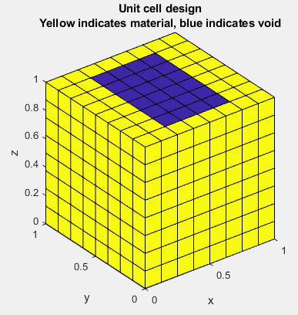 | 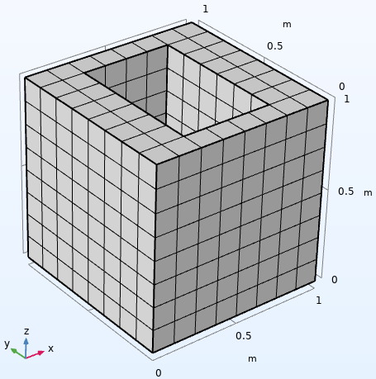

The dispersion relations computed by each match (only validating against sweep over x-component of wavevector, since 3D-dispersion-matlab has been extensively validated against Comsol already):
3D-dispersion-matlab | Comsol
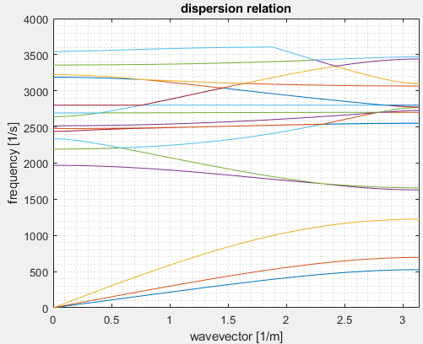 | 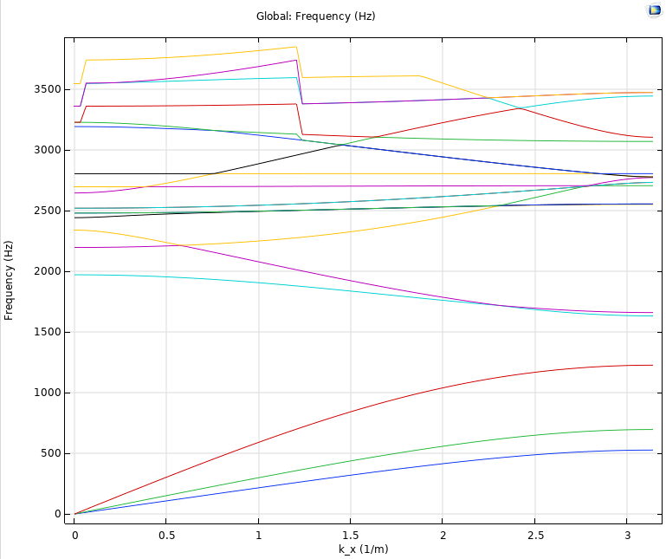
*Comsol seems to do a funky thing where it thinks some eigenvectors have multiplicity of 2, when really they don’t. See the higher bands for example.

